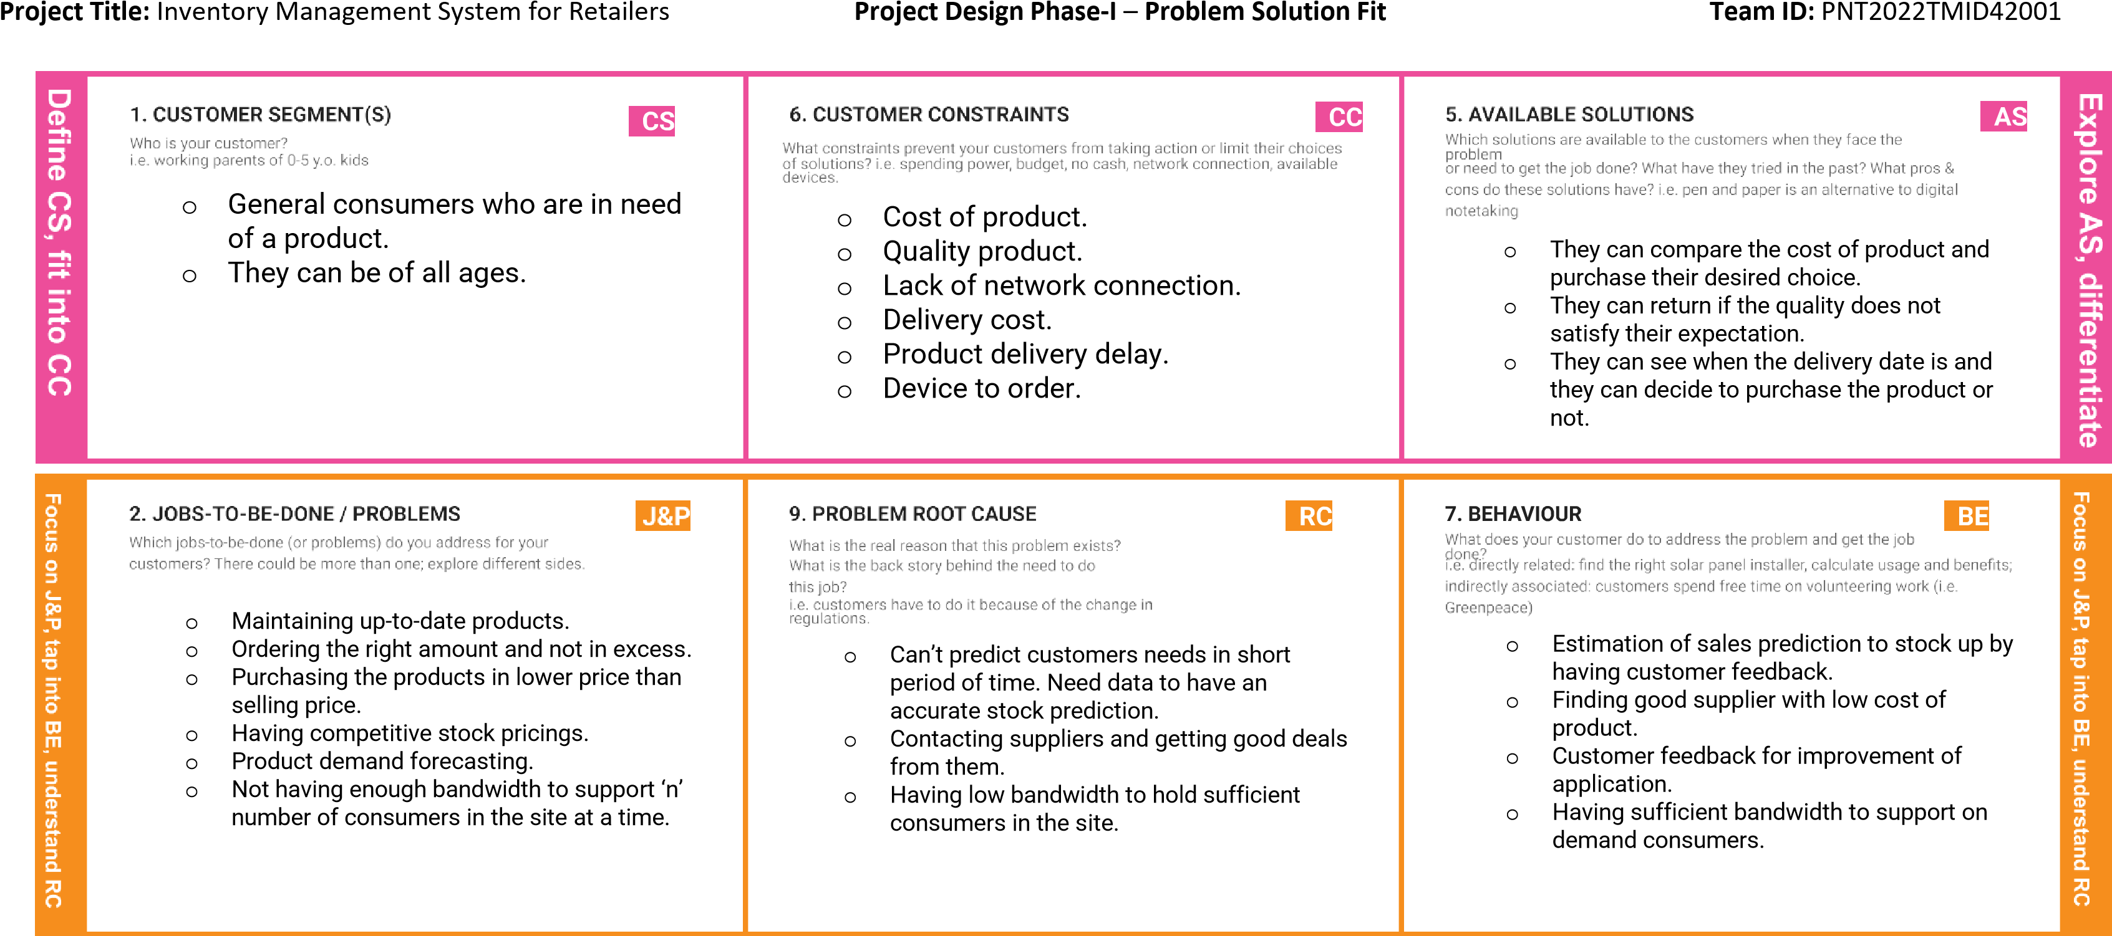

|  |  |  |  |  |
| --- | --- | --- | --- | --- |
|  | **3. TRIGGERS TR**  What triggers customers to act? i.e. seeing their neighbour installing solar panels,o readingCustomer about a more un efficientable to reach the application solution in the news.  due to high demand.  o Having the stock price high. o Lack of application service. | **10. YOUR SOLUTION SL**  If you are working on an existing business, write down your current solution first, fill in the canvas, and check how much it fits reality.  If you are working on a new business proposition, then keep it blank until you fill in the canvas and come up with a solution that fits within customer limitations, solves a problem and matches customer behavior.   * Deploying the application in a cloud server that tracks the real-time inventory and manages them. * Such as purchase details, sales, sales prediction, etc. * It sends an email to the retailers when the stocks are low and needs to be restocked. * Having a chatbot to guide and help the consumers who are having | 1. **CHANNELS of BEHAVIOUR CH**     1. **ONLINE**   What kind of actions do customers take online? Extract online channels from #7     * 1. **OFFLINE**   What kind of actions do customers take offline? Extract offline channels from #7 and use them for customer development.  ONLINE – Can access all the services and details.      OFFLINE - SMS notification for detailed list of enquiries. |  |
| **4. EMOTIONS: BEFORE / AFTER EM**  How do customers feel when they face a problem or a job and afterwards?  i.e.BEFORE lost, insecure > –confident, Untrus in controlted - use, worried, lack it in your communication of strategy & design. knowledge of stocks.    AFTER - Trusted, happy, referring to others, having sound knowledge of stocks, etc. |